**GALGOTIAS UNIVERSITY**

**DEPARTMENT OF COMPUTER SCIENCE AND ENGINEERING**



|  |  |  |  |
| --- | --- | --- | --- |
| **SUBJECT** | **Technical Training II** | **PROGRAMME** | **MCA** |
| **SUBJECT CODE** | **MCAN1002** | **SEMESTER** | **II** |
| **CREDITS** | **1** | **DURATION OF SEMESTER** | **15 Week** |
| **PREREQUISITE SUBJECTS** | **Basic Programming Knowledge** | **SESSION DURATION** | **2 Hours/Week** |

**Prepared Nidhi Gupta Approved**

1. **VISION AND MISSION OF GALGOTIAS UNIVERSITY**

**VISION**

* To be known globally for value-based education, research, creativity and innovation

**MISSION**

* Establish state-of-the-art facilities for world class education and research.
* Collaborate with industry and society to align the curriculum.
* Involve in societal outreach programs to identify concerns and provide sustainable ethical solutions.
* Encourage life-long learning and team-based problem solving through an enabling environment.

1. **VISION AND MISSION OF DEPARTMENT**

**VISION**

* To be known globally as a premier department of computer science and engineering for value-based education, multi-disciplinary research and innovation.

**MISSION**

* Create a strong foundation on fundamentals of computer science and engineering through outcome-based teaching- learning process.
* Establish state-of-art facilities for analysis design and implementation to develop sustainable ethical solution.
* Conduct multi-disciplinary research for developing innovative solution
* Involve the students in group activity including that of professional bodies to develop leadership and communication skills.

1. **PROGRAM EDUCATIONAL OBJECTIVES**

|  |  |
| --- | --- |
| PEO1 | Graduates of Computer Science and Engineering will be globally competent and provide sustainable solutions for interdisciplinary problems as team players |
| PEO2 | Graduates of Computer Science and Engineering will engage in professional activities with ethical practices in the field of Computer Science and Engineering to enhance their own stature to contribute towards society |
| PEO3 | Graduates of Computer Science and Engineering will acquire specialized knowledge in emerging technologies for research, innovation and product development. |
| 1. **PROGRAMME OUTCOMES** | |
| PO1 | **Engineering knowledge:** Apply the knowledge of mathematics, science, engineering fundamentals, and an engineering specialization to the solution of complex engineering problems. |
| PO2 | **Problem analysis:** Identify, formulate, review research literature, and analyze complex engineering problems reaching substantiated conclusions using first principles of mathematics, natural sciences, and engineering sciences. |
| PO3 | **Design/development of solutions:** Design solutions for complex engineering problems and design system components or processes that meet the specified needs with appropriate consideration for the public health and safety, and the cultural, societal, and environmental considerations. |
| PO4 | **Conduct investigations of complex problems:** Use research-based knowledge and research methods including design of experiments, analysis and interpretation of data, and synthesis of the information to provide valid conclusions |
| PO5 | **Modern tool usage:** Create, select, and apply appropriate techniques, resources, and modern engineering and IT tools including prediction and modeling to complex engineering activities with an understanding of the limitations. |
| PO6 | **The engineer and society:** Apply reasoning informed by the contextual knowledge to assess societal, health, safety, legal and cultural issues and the consequent responsibilities relevant to the professional engineering practice. |
| PO7 | **Environment and sustainability:** Understand the impact of the professional engineering solutions in societal and environmental contexts, and demonstrate the knowledge of, and need for sustainable development |
| PO8 | **Ethics**: Apply ethical principles and commit to professional ethics and responsibilities and norms of the engineering practice. |
| PO9 | **Individual and team work:** Function effectively as an individual, and as a member or leader in diverse teams, and in multidisciplinary settings. |
| PO10 | **Communication:** Communicate effectively on complex engineering activities with the engineering community and with society at large, such as, being able to comprehend and write effective reports and design documentation, make effective presentations, and give and receive clear instructions. |
| PO11 | **Project management and finance:** Demonstrate knowledge and understanding of the engineering and management principles and apply these to one’s own work, as a member and leader in a team, to manage projects and in multidisciplinary environments. |
| PO12 | **Life-long learning:** Recognize the need for, and have the preparation and ability to engage in independent and life-long learning in the broadest context of technological change. |
| 1. **Programme specifics Outcome (PSO)** | |
| PSO1 | Able to analyze, design and implement sustainable and ethical solutions in the field of computer science. |
| PSO2 | Able to use problem solving skills to develop efficient algorithmic solutions. |

1. **EXPERIMENTAL SETUP DETAILS FOR THE COURSE**

**Software Requirements**

* Any Operating System, JDK1.8 or above, IDE: Eclipse IDE, NetBeans, IntelliJ

**Hardware Requirements**

* No specific requirements. Any computer Hardware capable of running DOS or any OS can be used for this course.

1. **COURSE OUTCOMES (COs)**

|  |  |  |  |
| --- | --- | --- | --- |
| **Course Outcomes (COs): At the end of the course, the student will be able to** | | | |
| **CO No.** | **Course Outcomes (Action verb should be in italics)** | **Bloom’s**  **taxonomy** | **Bloom’s**  **Level** |
| CO1 | Apply the basic concepts of java to solve various programming problem. | Apply | **K3** |
| CO2 | Apply database connectivity using Java | Apply | **K3** |
| CO3 | Design and normalize the Database | Apply | **K3** |
| CO4 | Formulate the queries to perform DDL/DML/Join/Grouping operations | Apply | **K3** |
| CO5 | Apply different data structure to solve the problems. | Apply | **K3** |
| CO6 | Optimize the solutions of different programming problems using dynamic programming. | Apply | **K3** |

1. **CO-PO-PSO MAPPING**

|  |  |  |  |  |  |  |  |  |  |  |  |  |  |  |
| --- | --- | --- | --- | --- | --- | --- | --- | --- | --- | --- | --- | --- | --- | --- |
| **CO/PO Mapping**  (S/M/W indicates strength of correlation) S-Strong, M-Medium, L-Low | | | | | | | | | | | | | | |
| CO’s | **Program Outcomes (POs)** | | | | | | | | | | | | | |
| PO1 | PO2 | PO3 | PO4 | PO5 | PO6 | PO7 | PO8 | PO9 | PO10 | PO11 | PO12 | PSO1 | PSO2 |
| CO1 | 2 |  | 1 |  | 2 |  |  |  |  |  |  | 2 | 1 |  |
| CO2 | 1 |  | 1 |  | 2 |  |  |  |  |  |  | 1 | 1 |  |
| CO3 | 1 | 1 |  |  | 2 |  |  |  |  |  |  |  |  |  |
| CO4 | 1 | 1 |  |  | 2 |  |  |  |  |  |  |  | 1 |  |
| CO5 |  |  |  |  |  |  |  |  |  |  |  |  |  |  |
| CO6 | 1 | 1 |  |  | 3 |  |  |  |  |  |  | 2 | 1 |  |

**8.1 Relationship between the COs and Program Outcomes POs**

|  |  |  |  |
| --- | --- | --- | --- |
| **S. No.** | **Course Outcomes** | **Mapped Program Outcomes** | **Mapping of Course Outcome with Assessment** |
| 1 | Apply the basic concepts of java to solve various programming problem. | PO1, PO3, PO5, PO12,PSO1 | Quiz-1, Quiz-2, VPL1,VPL2, VPL3 |
| 2 | Apply database connectivity using Java | PO1, PO3,PO5, PO12,PSO1 | Quiz-3, Quiz-4, VPL4, VPL5, VPL6 |
| 3 | Design and normalize the Database | PO1, PO2, PO5 | Quiz-5, |
| 4 | Formulate the queries to perform DDL/DML/Join/Grouping operations | PO1, PO2, PO5, PSO1 | Quiz-6 |
| 5 | Apply different data structure to solve the problems. |  | Quiz 7 |
| 6 | Optimize the solutions of different programming problems using dynamic programming. |  | Quiz 8 |

1. **LAB EVALUATION SCHEME**

**Mode of Evaluation:**

|  |  |  |  |  |
| --- | --- | --- | --- | --- |
| **S. No.** | **Evaluation Component** | **Duration** | **Marks (100) (%)** | **Nature of Component** |
| 1. | Quizzes | 1 hours per quiz | 30 | On Line |
| 2. | VPL | 1 hours per VPL | 40 | On Line |
| 3 | Final Assessment | 3 hours | 30 | On Line |

1. **Rubrics for final assessment**

|  |  |  |
| --- | --- | --- |
| **S. No.** | **Rubrics – Parts** | **Marks** |
| 1 | Able to understand the problem statement | **5** |
| 2 | Able to convert the problem statement into program | **5** |
| 3 | Quiz | **20** |
| 4 | Logical Programming using LMS | **30** |
| **Total** | | **70** |

1. **Assessment format**

**GALGOTIAS UNIVERSITY**

**Department of Computer Science and Engineering**

**Internal Assessment**

**Subject Code : Subject Name :**

**Session : Class :**

**Date : Max. Marks :**

|  |  |  |  |  |  |
| --- | --- | --- | --- | --- | --- |
| **S. No** | **Enrollment No.** | **Name of the Student** | **Quizzes** | **VPLs** | **Total (70)** |
|  |  |  |  |  |  |
|  |  |  |  |  |  |
|  |  |  |  |  |  |
|  |  |  |  |  |  |
|  |  |  |  |  |  |

**GALGOTIAS UNIVERSITY**

**Department of Computer Science and Engineering**

**Final Assessment**

**Subject Code : Subject Name :**

**Session : Class :**

**Date : Max. Marks :**

|  |
| --- |
| **External Lab Assessment (End Semester)** |

|  |  |  |  |  |  |  |
| --- | --- | --- | --- | --- | --- | --- |
| **S. No.** | **Enrollment. No.** | **Name of the Student** | **Internal Assessment Test (70)** | **External Assessment Test (30)** | **Total (100)** | **Marks (in words)** |
| **1.** |  |  |  |  |  |  |
| **2.** |  |  |  |  |  |  |
| **3.** |  |  |  |  |  |  |
| **4.** |  |  |  |  |  |  |
| **5.** |  |  |  |  |  |  |

1. **SYLLABUS:**

**PRE-REQUISITES**

* Basic Knowledge of Computer
* Basic Knowledge of Programming

**COURSE CONTENTS:**

**Module 1:**

## Unit I: Basics of Java (Revised)

Variables, Operators, import other Java packages to make them accessible in your code, overloading, Create and overload constructors; including impact on default constructors, Apply access modifiers, Apply encapsulation principles to a class, Wrapper class, Develop code that uses wrapper classes such as Boolean, Double, and Integer. Inheritance, Develop code that demonstrates the use of polymorphism; including overriding and object type versus reference type. Abstract classes and interfaces. Exception Handling.

## Unit II: String and Collections

Collection - Collection framework and collection interfaces List, Queue, Set and Map List classes- ArrayList, LinkedList, For-each method for collection and iterators, Map – HashMap, LinkedHashMap, Set classes- TreeSet, HashSet. Manipulate data using the StringBuilder class and its methods, Creating and manipulating Strings, Create and manipulate calendar data using classes from java.time package. Introduction to JDBC API, Types of drivers Statement, Prepared Statement and Callable Statement, ResultSet, Performing insert, update and delete operations.

**Module 2:**

## Unit III: Relational data Model and Language

Relational data model concepts, Data modelling using the Entity Relationship Model: ER model concepts, notation for ER diagram, mapping constraints, keys, Concepts of Super Key, candidate key, primary key, Generalization, aggregation, reduction of an ER diagrams to tables, extended ER model, relationship of higher degree. Integrity constraints, entity integrity, referential integrity, Keys constraints, Domain constraints, relational algebra, relational calculus, tuple and domain calculus.

## Unit IV: Data Base Design & Normalization

Introduction on SQL, Types of SQL commands, SQL operators and their procedure. Tables, views and indexes. Queries and sub queries. Aggregate functions, Insert, update and delete operations, Joins, Unions, Intersection, Minus, Cursors, Triggers, Procedures in SQL/PL SQL. Functional dependencies, normal forms, first, second, third normal forms, BCNF, inclusion dependence, loss less join decompositions, normalization using FD, MVD, and JDs, alternative approaches to database design.

**Module 3:**

## Unit V: Data Structure Basics (Revised)

Introduction to linear & nonlinear data structure, Abstract characterizations as well as the design and implementation of data structures such as arrays, stacks, queues, linked lists, binary search trees, heaps, and graphs along with algorithms that make use of such structures including algorithms for sorting, searching, and memory management. Algorithms analysis using asymptotic behavior in terms of time complexity and space requirements

## Unit VI: Dynamic Programming

Introduction to Dynamic Programming, Memorization, Tabulation, Longest Common Subsequence with printing of subsequence, Longest Increasing Subsequence, Coin change problem, Egg Drop Problem.

**Text Books:**

1. Kathy Sierra, and Bates Bert. Head First Java: A Brain-Friendly Guide. " O'Reilly Media, Inc.", Second Edition, 2009.
2. James Rumbaugh et. al, “Object Oriented Modeling and Design”, Prentice-Hall; 1st edition, 1990.
3. “Database system concepts” Henry F Korth, Abraham Silberschatz, S. Sudurshan, McGraw-

Hill

1. Francis, A. (1987). Schaum's outline series: Programing with advanced structural cobol: Lawrence R. Newcomer. McGraw-Hill.

**Reference Books:**

1. Naughton, Schildt, “The Complete Reference JAVA2”, TMH, 3rd Edition, 1999.
2. Kathy Sierra, and Bates Bert. Sun Certified Programmer for Java. McGraw Hill Publications, 2008.
3. Pandey, Tiwari, “ Object Oriented Programming with JAVA” , Acme Learning Private Limited; First Edition, 2009.
4. Horstmann, Cay S., and Gary Cornell. Core Java 2: Volume I, Fundamentals. Pearson Education, 9th Edition, 2013.
5. Date C J, “ An Introduction to Database Systems”, Addision Wesley
6. Elmasri, Navathe, “ Fudamentals of Database Systems”, Addision Wesley O’Neil, Databases, Elsevier Pub.
7. Majumdar& Bhattacharya, “Database Management System”, TMH (14)
8. TEACHING PEDAGOGY:

Black Board, Power Point Presentations, Live Coding, Internet Resources, Student Exercises

1. Lesson Plan

|  |  |  |  |  |  |  |
| --- | --- | --- | --- | --- | --- | --- |
| **Sno** | **Date** | **Topics to be covered** | **outcomes of each topic** | **Total labs in the Unit** | **Related Unit of syllabus** | **Reference** |
| **Chap./Sec. (Book)** |
| **(T1 means test book in serial 1 and so on** |
| **R1 means reference book in serial no 1 and so on)** |
| 1 | 10-03-2022 | Variables, Operators, import other Java packages to make them accessible in your code |  | 10 | 1 | T1,R1 |
| 2 | 16-12-2020 | , overloading, Create and overload constructors |  |
| 3 | 22-12-2020 | including impact on default constructors, Apply access modifiers |  |
| 4 | 23-12-2020 | Apply encapsulation principles to a class |  |
| 5 | 04-01-2021 | Wrapper class, Develop code that uses wrapper classes such as Boolean, Double, and Integer |  |
| 6 | 05-01-2021 | Inheritance, Develop code that demonstrates the use of polymorphism; including overriding and object type versus reference type |  |
| 7 | 06-01-2021 | Inheritance, Develop code that demonstrates the use of polymorphism; including overriding and object type versus reference type |  |
| 8 | 11-01-2021 | Abstract classes and interfaces |  |
| 9 | 12-01-2021 | Exception Handling |  |
| 10 | 13-01-2021 | Exception Handling |  |
| 11 | 18-01-2021 | Collection - Collection framework |  | 10 | 2 | T1,R2 |
| 12 | 19-01-2021 | collection interfaces List, Queue, Set and Map List classes- ArrayList, LinkedList, For-each method for collection and iterators, Map – HashMap, LinkedHashMap, Set classes- TreeSet, HashSet |  |
| 13 | 20-01-2021 | collection interfaces List, Queue, Set and Map List classes- ArrayList, LinkedList, For-each method for collection and iterators, Map – HashMap, LinkedHashMap, Set classes- TreeSet, HashSet |  |
| 14 | 25-01-2021 | Manipulate data using the StringBuilder class and its methods |  |
| 15 | 01-02-2021 | Creating and manipulating Strings |  |
| 16 | 02-02-2021 | Creating and manipulating Strings |  |
| 17 | 03-02-2021 | Create and manipulate calendar data using classes from java.time package |  |
| 18 | 08-02-2021 | Introduction to JDBC API, Types of drivers Statement |  |
| 19 | 09-02-2021 | Prepared Statement and Callable Statement |  |
| 20 | 10-02-2021 | ResultSet, Performing insert, update and delete operations |  |
| 21 | 15-02-2021 | ResultSet, Performing insert, update and delete operations |  |
| 22 | 17-02-2021 | Relational data model concepts |  | 10 | 3 | T2,R1 |
| 23 | 22-02-2021 | Data modelling using the Entity Relationship Model: ER model concepts, notation for ER diagram |  |
| 24 | 23-02-2021 | mapping constraints, keys, Concepts of Super Key, candidate key, primary key |  |
| 25 | 24-02-2021 | Generalization, aggregation, reduction of an ER diagrams to tables, |  |
| 26 | 01-03-2021 | Generalization, aggregation, reduction of an ER diagrams to tables, |  |
| 27 | 02-03-2021 | extended ER model, relationship of higher degree |  |
| 28 | 03-03-2021 | Integrity constraints, entity integrity, referential integrity, Keys constraints |  |
| 29 | 08-03-2021 | Domain constraints, relational algebra, relational calculus, tuple and domain calculus. |  |
| 30 | 09-03-2021 | Domain constraints, relational algebra, relational calculus, tuple and domain calculus. |  |
| 31 | 10-03-2021 | Introduction on SQL, Types of SQL commands, SQL operators and their procedure |  | 10 | 4 | T2,R2 |
| 32 | 11-03-2021 | Tables, views and indexes |  |
| 33 | 12-03-2021 | Queries and sub queries. Aggregate functions, Insert, update and delete operations |  |
| 34 | 13-03-2021 | Joins, Unions, Intersection, Minus, Cursors, Triggers, Procedures in SQL/PL SQL |  |
| 35 | 14-03-2021 | Joins, Unions, Intersection, Minus, Cursors, Triggers, Procedures in SQL/PL SQL |  |
| 36 | 15-03-2021 | Functional dependencies, normal forms, first, second, third normal forms |  |
| 37 | 16-03-2021 | Functional dependencies, normal forms, first, second, third normal forms |  |
| 38 | 17-03-2021 | BCNF, inclusion dependence, loss less join decompositions |  |
| 39 | 18-03-2021 | normalization using FD, MVD, and JDs, alternative approaches to database design. |  |
| 40 | 19-03-2021 | normalization using FD, MVD, and JDs, alternative approaches to database design. |  |
| 41 | 20-03-2021 | Introduction to linear & nonlinear data structure |  | 16 | 5 | T3,R1 |
| 42 | 21-03-2021 | Abstract characterizations as well as the design and implementation of data structures |  |
| 43 | 22-03-2021 | arrays, stacks, queues, linked lists, binary search trees, heaps, and graphs along with algorithms |  |
| 44 | 23-03-2021 | arrays, stacks, queues, linked lists, binary search trees, heaps, and graphs along with algorithms |  |
| 45 | 24-03-2021 | algorithms for sorting, searching, and memory management |  |
| 46 | 25-03-2021 | algorithms for sorting, searching, and memory management |  |
| 47 | 26-03-2021 | Algorithms analysis using asymptotic behavior in terms of time complexity and space requirements |  |
| 48 | 27-03-2021 | Algorithms analysis using asymptotic behavior in terms of time complexity and space requirements |  |
| 49 | 28-03-2021 | Introduction to Dynamic Programming |  | 8 | 6 | T3,R2 |
| 50 | 29-03-2021 | Memorization, Tabulation |  |
| 51 | 30-03-2021 | Memorization, Tabulation |  |
| 52 | 31-03-2021 | Longest Common Subsequence with printing of subsequence |  |
| 53 | 01-04-2021 | Longest Increasing Subsequence |  |
| 54 | 02-04-2021 | Coin change problem |  |
| 55 | 03-04-2021 | , Egg Drop Problem. |  |

1. QUESTIONS BANK (Partial list, more activities can be added by faculty)

**Quizzes:**

1. Fundamentals Quiz
2. Java Architecture
3. Conditional Statement
4. Quiz based on Classes and Objects Edit title

**VPL:**

1. Largest Between 3 Numbers
2. Write a program to check weather number is palindrome or not
3. Write a program to find the Nth term in the series.
4. Sum of digits Of A Number
5. Calculate area and circumference of circle in Java
6. Sample Quiz

## Consider the given code snippet and select the correct answer.

| Consider the given code snippet and select the correct answer.  for(int i=1, j=1; i<5 ; i++, j++)      System.out.print(i+j); | | | MC |
| --- | --- | --- | --- |
| Default mark: | | | 1 |
| Shuffle the choices? | | | Yes |
| Number the choices? | | | a |
| Penalty for each incorrect try: | | | 33.3 |
| 1. # | Answers | Feedback | Grade |
|  | 2468 |  | 100 |
|  | 12345 |  | 0 |
|  | 11223344 |  | 0 |
|  | Error |  | 0 |
|  | General feedback: |  |  |
|  | For any correct response: | Your answer is correct. |  |
|  | For any incorrect response: | Your answer is incorrect. |  |
|  | Hint 1: |  |  |
|  | Show the number of correct responses (Hint 1): | No |  |
|  | Clear incorrect responses (Hint 1): | No |  |
|  | Tags: |  |  |
| *Allows the selection of a single or multiple responses from a pre-defined list. (MC/MA)* | | |  |

## How many times "Hello world!" will be printed? (Consider the following code snippet).

| How many times "Hello world!" will be printed? (Consider the following code snippet).  int x = 2;  int y = 8;  while(x<(y+5))  {      System.out.println("Hello world!");      x+=2;      y-=2;  } | | | MC |
| --- | --- | --- | --- |
| Default mark: | | | 1 |
| Shuffle the choices? | | | Yes |
| Number the choices? | | | a |
| Penalty for each incorrect try: | | | 33.3 |
| 1. # | Answers | Feedback | Grade |
|  | 3 |  | 100 |
|  | 4 |  | 0 |
|  | 5 |  | 0 |
|  | 6 |  | 0 |
|  | General feedback: |  |  |
|  | For any correct response: | Your answer is correct. |  |
|  | For any incorrect response: | Your answer is incorrect. |  |
|  | Hint 1: |  |  |
|  | Show the number of correct responses (Hint 1): | No |  |
|  | Clear incorrect responses (Hint 1): | No |  |
|  | Tags: |  |  |
| *Allows the selection of a single or multiple responses from a pre-defined list. (MC/MA)* | | |  |

## What is the extension of compiled java classes?

| What is the extension of compiled java classes? | | | MC |
| --- | --- | --- | --- |
| Default mark: | | | 1 |
| Shuffle the choices? | | | Yes |
| Number the choices? | | | a |
| Penalty for each incorrect try: | | | 33.3 |
| 1. # | Answers | Feedback | Grade |
|  | .class |  | 100 |
|  | .java |  | 0 |
|  | .txt |  | 0 |
|  | .js |  | 0 |
|  | General feedback: |  |  |
|  | For any correct response: | Your answer is correct. |  |
|  | For any incorrect response: | Your answer is incorrect. |  |
|  | Hint 1: |  |  |
|  | Show the number of correct responses (Hint 1): | No |  |
|  | Clear incorrect responses (Hint 1): | No |  |
|  | Tags: |  |  |
| *Allows the selection of a single or multiple responses from a pre-defined list. (MC/MA)* | | |  |

## What is the extension of java code files?

| What is the extension of java code files? | | | MC |
| --- | --- | --- | --- |
| Default mark: | | | 1 |
| Shuffle the choices? | | | Yes |
| Number the choices? | | | a |
| Penalty for each incorrect try: | | | 33.3 |
| 1. # | Answers | Feedback | Grade |
|  | .class |  | 0 |
|  | .java |  | 100 |
|  | .txt |  | 0 |
|  | .js |  | 0 |
|  | General feedback: |  |  |
|  | For any correct response: | Your answer is correct. |  |
|  | For any incorrect response: | Your answer is incorrect. |  |
|  | Hint 1: |  |  |
|  | Show the number of correct responses (Hint 1): | No |  |
|  | Clear incorrect responses (Hint 1): | No |  |
|  | Tags: |  |  |
| *Allows the selection of a single or multiple responses from a pre-defined list. (MC/MA)* | | |  |

## What is the output of this program?

| What is the output of this program?  class selection_statements      {          public static void main(String args[])          {              int var1 = 5;              int var2 = 6;              if ((var2 = 1) == var1)                  System.out.print(var2);              else                  System.out.print(++var2);          }      } | | | MC |
| --- | --- | --- | --- |
| Default mark: | | | 1 |
| Shuffle the choices? | | | Yes |
| Number the choices? | | | a |
| Penalty for each incorrect try: | | | 33.3 |
| 1. # | Answers | Feedback | Grade |
|  | 1 |  | 0 |
|  | 2 |  | 100 |
|  | 3 |  | 0 |
|  | 4 |  | 0 |
|  | General feedback: |  |  |
|  | For any correct response: | Your answer is correct.  Explanation: var2 is initialised to 1. The conditional statement returns false and the else part gets executed. |  |
|  | For any incorrect response: | Your answer is incorrect.  Explanation: var2 is initialised to 1. The conditional statement returns false and the else part gets executed. |  |
|  | Hint 1: |  |  |
|  | Show the number of correct responses (Hint 1): | No |  |
|  | Clear incorrect responses (Hint 1): | No |  |
|  | Tags: |  |  |
| *Allows the selection of a single or multiple responses from a pre-defined list. (MC/MA)* | | |  |

## What is the output of this program?

| What is the output of this program?      class comma_operator      {          public static void main(String args[])          {               int sum = 0;               for (int i = 0, j = 0; i < 5 & j < 5; ++i, j = i + 1)                   sum += i;         System.out.println(sum);          }      } | | | MC |
| --- | --- | --- | --- |
| Default mark: | | | 1 |
| Shuffle the choices? | | | Yes |
| Number the choices? | | | a |
| Penalty for each incorrect try: | | | 33.3 |
| 1. # | Answers | Feedback | Grade |
|  | compilation error |  | 0 |
|  | 5 |  | 0 |
|  | 6 |  | 100 |
|  | 14 |  | 0 |
|  | General feedback: |  |  |
|  | For any correct response: | Your answer is correct. |  |
|  | For any incorrect response: | Your answer is incorrect. |  |
|  | Hint 1: |  |  |
|  | Show the number of correct responses (Hint 1): | No |  |
|  | Clear incorrect responses (Hint 1): | No |  |
|  | Tags: |  |  |
| *Allows the selection of a single or multiple responses from a pre-defined list. (MC/MA)* | | |  |

## What is the valid data type for variable “a” to print “Hello World”?

| What is the valid data type for variable “a” to print “Hello World”?  switch(a)  {     System.out.println("Hello World");  } | | | MC |
| --- | --- | --- | --- |
| Default mark: | | | 1 |
| Shuffle the choices? | | | Yes |
| Number the choices? | | | a |
| Penalty for each incorrect try: | | | 33.3 |
| 1. # | Answers | Feedback | Grade |
|  | int and float |  | 0 |
|  | byte and short |  | 0 |
|  | char and long |  | 0 |
|  | byte and char |  | 100 |
|  | General feedback: |  |  |
|  | For any correct response: | Your answer is correct. |  |
|  | For any incorrect response: | Your answer is incorrect. |  |
|  | Hint 1: |  |  |
|  | Show the number of correct responses (Hint 1): | No |  |
|  | Clear incorrect responses (Hint 1): | No |  |
|  | Tags: |  |  |
| *Allows the selection of a single or multiple responses from a pre-defined list. (MC/MA)* | | |  |

## What is the valid data type for variable “a” to print “Hello World”?

| What is the valid data type for variable “a” to print “Hello World”?  switch(a)  {     System.out.println("Hello World");  } | | | MC |
| --- | --- | --- | --- |
| Default mark: | | | 1 |
| Shuffle the choices? | | | Yes |
| Number the choices? | | | a |
| Penalty for each incorrect try: | | | 33.3 |
| 1. # | Answers | Feedback | Grade |
|  | int and float |  | 0 |
|  | byte and short |  | 0 |
|  | char and long |  | 0 |
|  | byte and char |  | 100 |
|  | General feedback: |  |  |
|  | For any correct response: | Your answer is correct. |  |
|  | For any incorrect response: | Your answer is incorrect. |  |
|  | Hint 1: |  |  |
|  | Show the number of correct responses (Hint 1): | No |  |
|  | Clear incorrect responses (Hint 1): | No |  |
|  | Tags: |  |  |
| *Allows the selection of a single or multiple responses from a pre-defined list. (MC/MA)* | | |  |

## What is true about a break?

| What is true about a break? | | | MC |
| --- | --- | --- | --- |
| Default mark: | | | 1 |
| Shuffle the choices? | | | Yes |
| Number the choices? | | | a |
| Penalty for each incorrect try: | | | 33.3 |
| 1. # | Answers | Feedback | Grade |
|  | Break stops the execution of the entire program |  | 0 |
|  | Break halts the execution and forces the control out of the loop |  | 100 |
|  | Break forces the control out of the loop and starts the execution of the next iteration |  | 0 |
|  | Break halts the execution of the loop for certain time frame |  | 0 |
|  | General feedback: |  |  |
|  | For any correct response: | Your answer is correct. |  |
|  | For any incorrect response: | Your answer is incorrect. |  |
|  | Hint 1: |  |  |
|  | Show the number of correct responses (Hint 1): | No |  |
|  | Clear incorrect responses (Hint 1): | No |  |
|  | Tags: |  |  |
| *Allows the selection of a single or multiple responses from a pre-defined list. (MC/MA)* | | |  |

## What is true about do statement?

| What is true about the do statement? | | | MC |
| --- | --- | --- | --- |
| Default mark: | | | 1 |
| Shuffle the choices? | | | Yes |
| Number the choices? | | | a |
| Penalty for each incorrect try: | | | 33.3 |
| 1. # | Answers | Feedback | Grade |
|  | do statement executes the code of a loop at least once |  | 100 |
|  | do statement does not get execute if condition is not matched in the first iteration |  | 0 |
|  | do statement checks the condition at the beginning of the loop |  | 0 |
|  | do statement executes the code more than once always |  | 0 |
|  | General feedback: |  |  |
|  | For any correct response: | Your answer is correct. |  |
|  | For any incorrect response: | Your answer is incorrect. |  |
|  | Hint 1: |  |  |
|  | Show the number of correct responses (Hint 1): | No |  |
|  | Clear incorrect responses (Hint 1): | No |  |
|  | Tags: |  |  |
| *Allows the selection of a single or multiple responses from a pre-defined list. (MC/MA)* | | |  |

## What will be the output of following program?

| What will be the output of the following program?  public class temp  {      public static void main(String agrs[])      {          for(int i=1; i<=10; i++);          System.out.print(i);      }  } | | | MC |
| --- | --- | --- | --- |
| Default mark: | | | 1 |
| Shuffle the choices? | | | Yes |
| Number the choices? | | | a |
| Penalty for each incorrect try: | | | 33.3 |
| 1. # | Answers | Feedback | Grade |
|  | 12345678910 |  | 0 |
|  | 11 |  | 0 |
|  | Error |  | 100 |
|  | 1 2 3 4 5 6 7 8 9 10 |  | 0 |
|  | General feedback: |  |  |
|  | For any correct response: | Your answer is correct.  Cannot find symbol – **variable i**,**i** is a block variable that can be used with in loop body only. Statement  for(int i=1; i<=10; i++);  is terminated with semicolon (;) hence statement System.out.print(i); is not a part of loop. |  |
|  | For any incorrect response: | Your answer is incorrect.  Cannot find symbol – **variable i**,**i** is a block variable that can be used with in loop body only. Statement  for(int i=1; i<=10; i++);  is terminated with semicolon (;) hence statement System.out.print(i); is not a part of loop. |  |
|  | Hint 1: |  |  |
|  | Show the number of correct responses (Hint 1): | No |  |
|  | Clear incorrect responses (Hint 1): | No |  |
|  | Tags: |  |  |
| *Allows the selection of a single or multiple response from a pre-defined list. (MC/MA)* | | |  |

## What will be the output of following program?

| What will be the output of following program?  public class temp  {      public static void main(String agrs[])      {          int x[]={1,2,3,4,5};          for(int i=0; i<x.length;i++)              System.out.print(x[i]);      }  } | | | MC |
| --- | --- | --- | --- |
| Default mark: | | | 1 |
| Shuffle the choices? | | | Yes |
| Number the choices? | | | a |
| Penalty for each incorrect try: | | | 33.3 |
| 1. # | Answers | Feedback | Grade |
|  | Error – length is not a method of x. |  | 0 |
|  | 6 |  | 0 |
|  | 1,2,3,4,5 |  | 0 |
|  | 12345 |  | 100 |
|  | General feedback: |  |  |
|  | For any correct response: | Your answer is correct. |  |
|  | For any incorrect response: | Your answer is incorrect. |  |
|  | Hint 1: |  |  |
|  | Show the number of correct responses (Hint 1): | No |  |
|  | Clear incorrect responses (Hint 1): | No |  |
|  | Tags: |  |  |
| *Allows the selection of a single or multiple responses from a pre-defined list. (MC/MA)* | | |  |

## What will be the output of following program?

| What will be the output of following program?  public class temp { public static void main(String agrs[]) { for(int i=1, int j=1; i<5 ; i++, j++) System.out.print(i+""+j); } } | | | MC |
| --- | --- | --- | --- |
| Default mark: | | | 1 |
| Shuffle the choices? | | | Yes |
| Number the choices? | | | a |
| Penalty for each incorrect try: | | | 33.3 |
| 1. # | Answers | Feedback | Grade |
|  | 1122334455 |  | 0 |
|  | 12345 |  | 0 |
|  | 11223344 |  | 0 |
|  | Error |  | 100 |
|  | General feedback: |  |  |
|  | For any correct response: | Your answer is correct.  **Error**  Consider this statement int i=1, int j=1 we can not declare variables like that. Correct form is int i=1,j=1 correct loop statement is: for(int i=1,j=1; i<5; i++,j++) |  |
|  | For any incorrect response: | Your answer is incorrect.  **Error**  Consider this statement int i=1, int j=1 we can not declare variables like that. Correct form is int i=1,j=1 correct loop statement is: for(int i=1,j=1; i<5; i++,j++) |  |
|  | Hint 1: |  |  |
|  | Show the number of correct responses (Hint 1): | No |  |
|  | Clear incorrect responses (Hint 1): | No |  |
|  | Tags: |  |  |
| *Allows the selection of a single or multiple responses from a pre-defined list. (MC/MA)* | | |  |

## What will be the output of following program?

| What will be the output of following program?  public class temp  {      public static void main(String agrs[])      {            for(int i=1, j=1; i<5 ; i++, j++)              System.out.print(i+""+j);      }  } | | | MC |
| --- | --- | --- | --- |
| Default mark: | | | 1 |
| Shuffle the choices? | | | Yes |
| Number the choices? | | | a |
| Penalty for each incorrect try: | | | 33.3 |
| 1. # | Answers | Feedback | Grade |
|  | 1122334455 |  | 0 |
|  | 12345 |  | 0 |
|  | 11223344 |  | 100 |
|  | Error |  | 0 |
|  | General feedback: |  |  |
|  | For any correct response: | Your answer is correct. |  |
|  | For any incorrect response: | Your answer is incorrect. |  |
|  | Hint 1: |  |  |
|  | Show the number of correct responses (Hint 1): | No |  |
|  | Clear incorrect responses (Hint 1): | No |  |
|  | Tags: |  |  |
| *Allows the selection of a single or multiple responses from a pre-defined list. (MC/MA)* | | |  |

## What will be the output of the following program?

| What will be the output of the following program?  class Test {  public  static void main(String[] args)  {  final int a = 10, b = 20;  while (a > b) {  System.out.println("Hello");  }  System.out.println("JAVA");  }  } | | | MC |
| --- | --- | --- | --- |
| Default mark: | | | 1 |
| Shuffle the choices? | | | Yes |
| Number the choices? | | | a |
| Penalty for each incorrect try: | | | 33.3 |
| 1. # | Answers | Feedback | Grade |
|  | Compile-time error |  | 100 |
|  | JAVA |  | 0 |
|  | Hello |  | 0 |
|  | No Output |  | 0 |
|  | General feedback: |  |  |
|  | For any correct response: | Your answer is correct.  Two variables declared as [final](https://www.geeksforgeeks.org/final-keyword-java/). In the while loop, it always returns false and the control does not go inside while loop and it does not get the chance in the entire program. That's why we will get a compile-time error saying error: unreachable statement. |  |
|  | For any incorrect response: | Your answer is incorrect.  Two variables declared as [final](https://www.geeksforgeeks.org/final-keyword-java/). In the while loop, it always returns false and the control does not go inside while loop and it does not get the chance in the entire program. That's why we will get a compile-time error saying error: unreachable statement. |  |
|  | Hint 1: |  |  |
|  | Show the number of correct responses (Hint 1): | No |  |
|  | Clear incorrect responses (Hint 1): | No |  |
|  | Tags: |  |  |
| *Allows the selection of a single or multiple responses from a pre-defined list. (MC/MA)* | | |  |

## What would be the output of the following codesnippet if variable a=10?

| What would be the output of the following codesnippet if variable a=10?  if(a<=0)  {     if(a==0)     {       System.out.println("1 ");     }     else     {        System.out.println("2 ");     }  }  System.out.println("3 "); | | | MC |
| --- | --- | --- | --- |
| Default mark: | | | 1 |
| Shuffle the choices? | | | Yes |
| Number the choices? | | | a |
| Penalty for each incorrect try: | | | 33.3 |
| 1. # | Answers | Feedback | Grade |
|  | 1 2 |  | 0 |
|  | 2 3 |  | 0 |
|  | 1 3 |  | 0 |
|  | 3 |  | 100 |
|  | General feedback: |  |  |
|  | For any correct response: | Your answer is correct. |  |
|  | For any incorrect response: | Your answer is incorrect. |  |
|  | Hint 1: |  |  |
|  | Show the number of correct responses (Hint 1): | No |  |
|  | Clear incorrect responses (Hint 1): | No |  |
|  | Tags: |  |  |
| *Allows the selection of a single or multiple responses from a pre-defined list. (MC/MA)* | | |  |

## Which component is responsible to run java program?

| Which component is responsible to run java program? | | | MC |
| --- | --- | --- | --- |
| Default mark: | | | 1 |
| Shuffle the choices? | | | Yes |
| Number the choices? | | | a |
| Penalty for each incorrect try: | | | 33.3 |
| 1. # | Answers | Feedback | Grade |
|  | JVM |  | 0 |
|  | JDK |  | 0 |
|  | JRE |  | 100 |
|  | JIT |  | 0 |
|  | General feedback: |  |  |
|  | For any correct response: | Your answer is correct. |  |
|  | For any incorrect response: | Your answer is incorrect. |  |
|  | Hint 1: |  |  |
|  | Show the number of correct responses (Hint 1): | No |  |
|  | Clear incorrect responses (Hint 1): | No |  |
|  | Tags: |  |  |
| *Allows the selection of a single or multiple responses from a pre-defined list. (MC/MA)* | | |  |

## Which of the following is not a valid jump statement?

| Which of the following is not a valid jump statement? | | | MC |
| --- | --- | --- | --- |
| Default mark: | | | 1 |
| Shuffle the choices? | | | Yes |
| Number the choices? | | | a |
| Penalty for each incorrect try: | | | 33.3 |
| 1. # | Answers | Feedback | Grade |
|  | break |  | 0 |
|  | goto |  | 100 |
|  | continue |  | 0 |
|  | return |  | 0 |
|  | General feedback: |  |  |
|  | For any correct response: | Your answer is correct. |  |
|  | For any incorrect response: | Your answer is incorrect. |  |
|  | Hint 1: |  |  |
|  | Show the number of correct responses (Hint 1): | No |  |
|  | Clear incorrect responses (Hint 1): | No |  |
|  | Tags: |  |  |
| *Allows the selection of a single or multiple responses from a pre-defined list. (MC/MA)* | | |  |

1. **Sample VPL Programs**

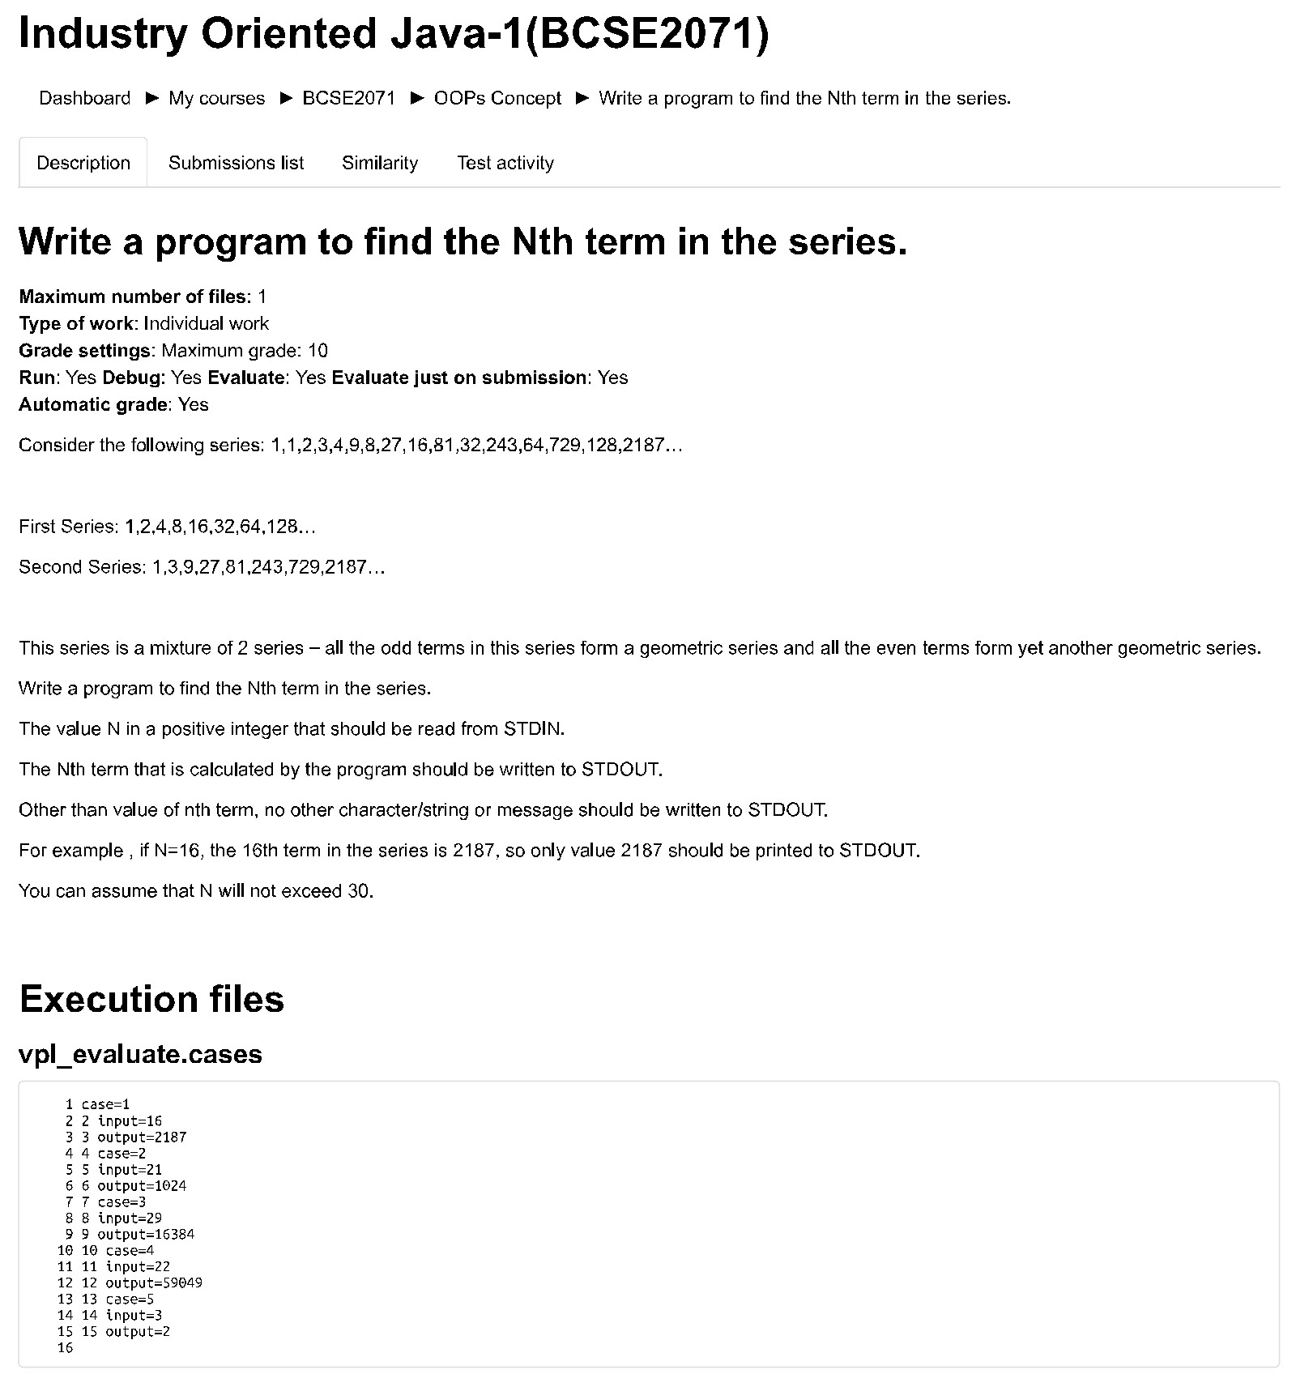

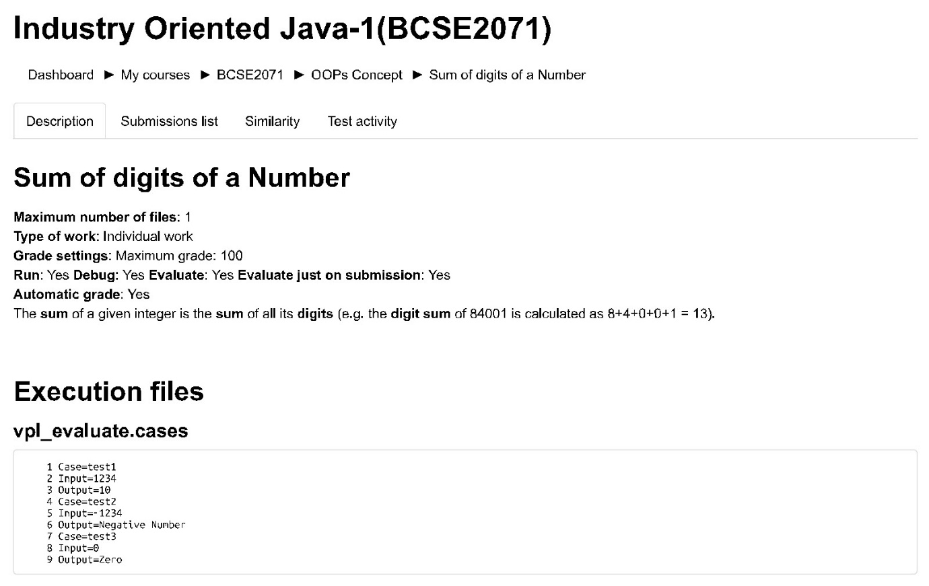

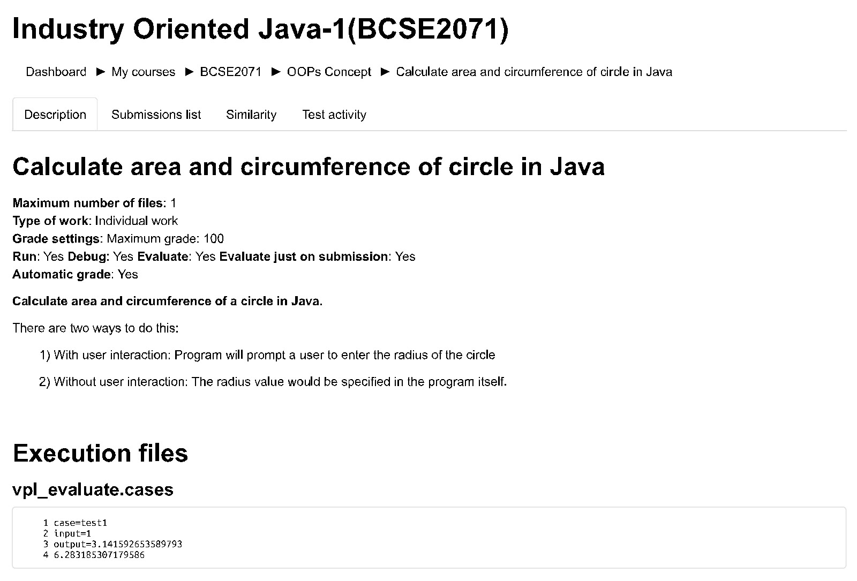

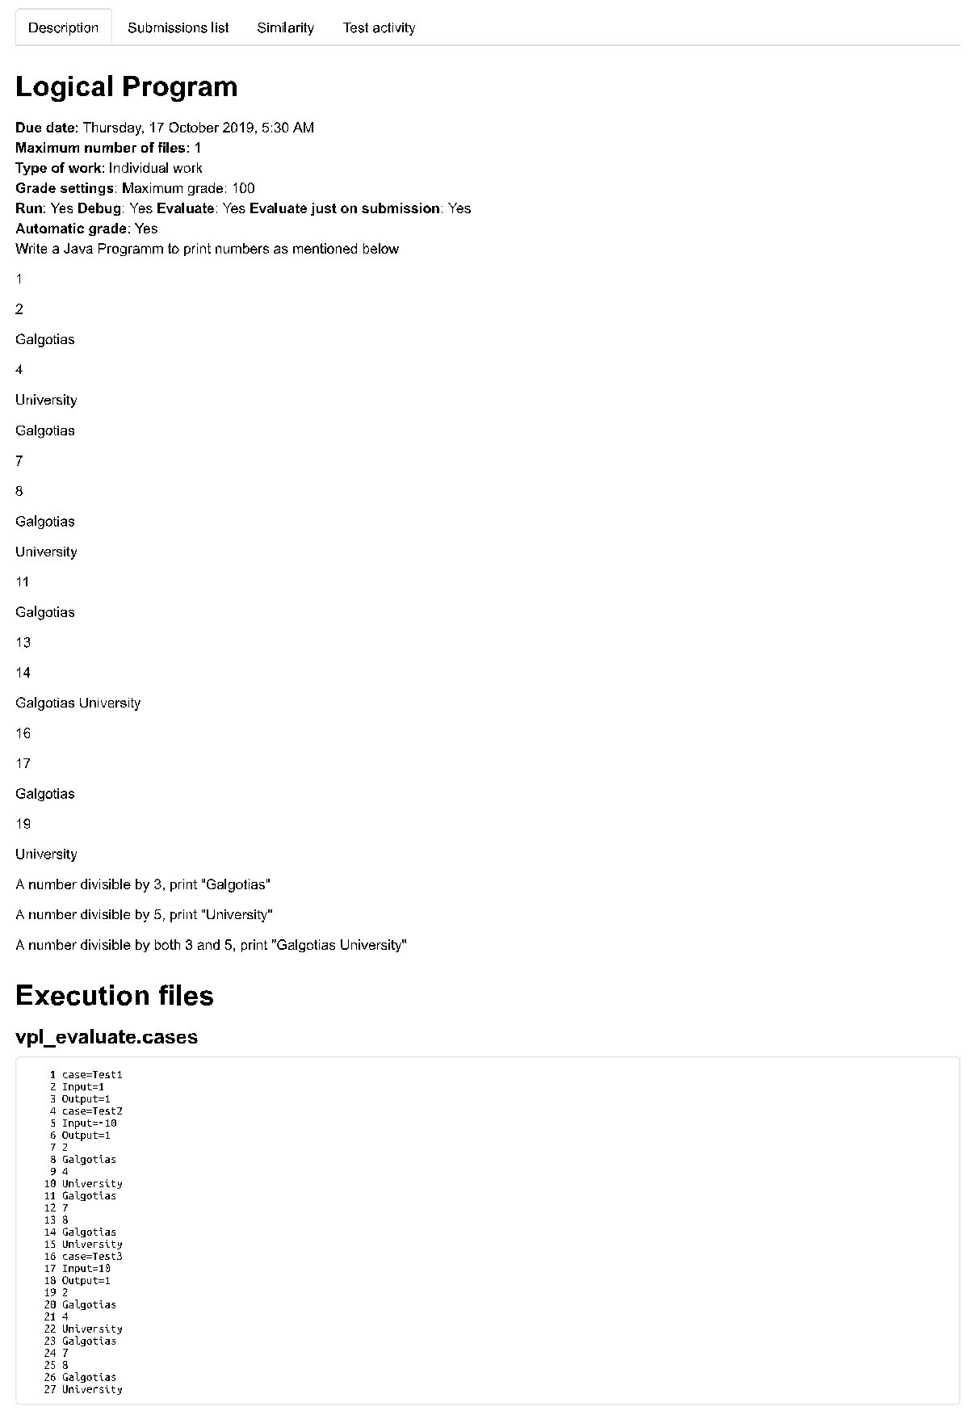

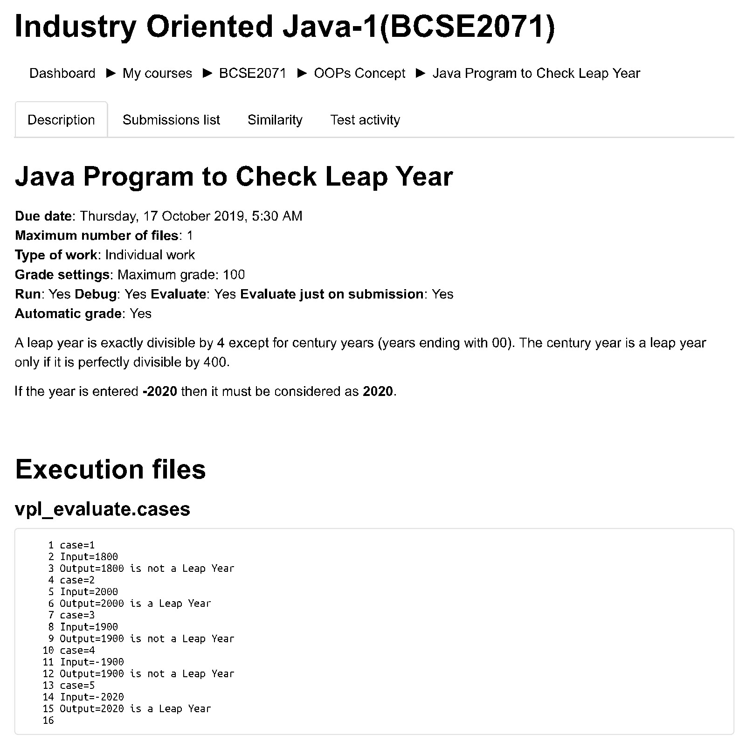

1. **Faculties List**

|  |  |
| --- | --- |
| **S. No** | **Faculties Name** |
|  | Dr.J.N. Singh |
|  | Dr. Tf. Michael raj |
|  |  |
|  |  |
|  |  |
|  |  |
|  |  |

**19. SLOW AND FAST LEARNER’S DETAILS**